**DAILY ONLINE ACTIVITIES SUMMARY**

|  |  |  |  |  |  |  |  |  |
| --- | --- | --- | --- | --- | --- | --- | --- | --- |
| **Date:** | **22/05/2020** | | | | | **Name:** | **POOJA D S** | |
| **Sem & Sec** | **4th SEM 'B' Section** | | | | | **USN:** | **4AL18CS056** | |
| **Online Test Summary** | | | | | | | | |
| **Subject** | | **Operating Systems** | | | | | | |
| **Max. Marks** | | **30** | | **Score** | | | **22** | |
| **Certification Course Summary** | | | | | | | | |
| **Course** | **Java Programming** | | | | | | | |
| **Certificate Provider** | | | **Great Learning Academy** | | **Duration** | | | **3.5 hour** |
| **Coding Challenges** | | | | | | | | |
| **Problem Statement:** A user will input two strings, and we find if one of the strings is a sub sequence of the other. Program prints “yes” if either the first string is a sub sequence of the second string or the second string is a sub sequence of the first string. Assume that, the length of the first string is smaller than or equal to the length of the second string. Assume that, the length of the first string is smaller than or equal to the length of the second string. | | | | | | | | |
| **Status: completed** | | | | | | | | |
| **Uploaded the report in Github** | | | | | **yes** | | | |
| **If yes Repository name** | | | | | <https://github.com/dspooja/C-coding> | | | |
| **Uploaded the report in slack** | | | | | **yes** | | | |

Online Test Details: (Attach the snapshot and briefly write the report for the same)

Certification Course Details: (Attach the snapshot and briefly write the report for the same)

Coding Challenges Details: (Attach the snapshot and briefly write the report for the same)

ONLINE TEST DETAILS:

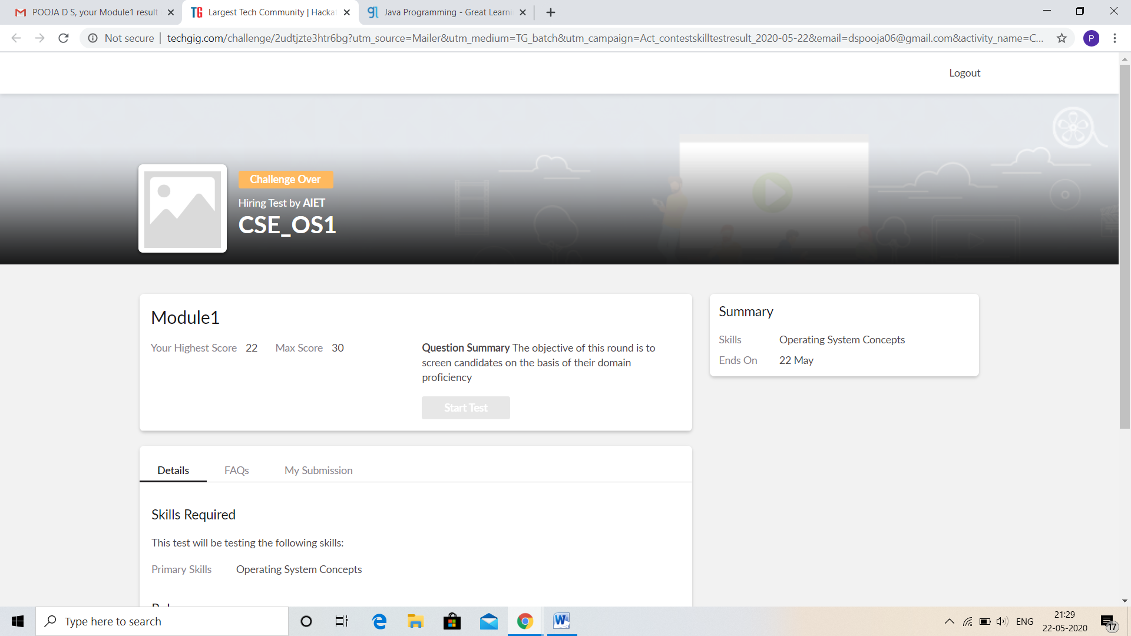

CERTIFICATION COURSE DETAILS:

* My Certification Course is Java Programming
* **The concepts covered in Java Programming are:**
* Agenda
* What is Java
* Install Java & Java IDE
* First Java Programming
* Variables and Data Types

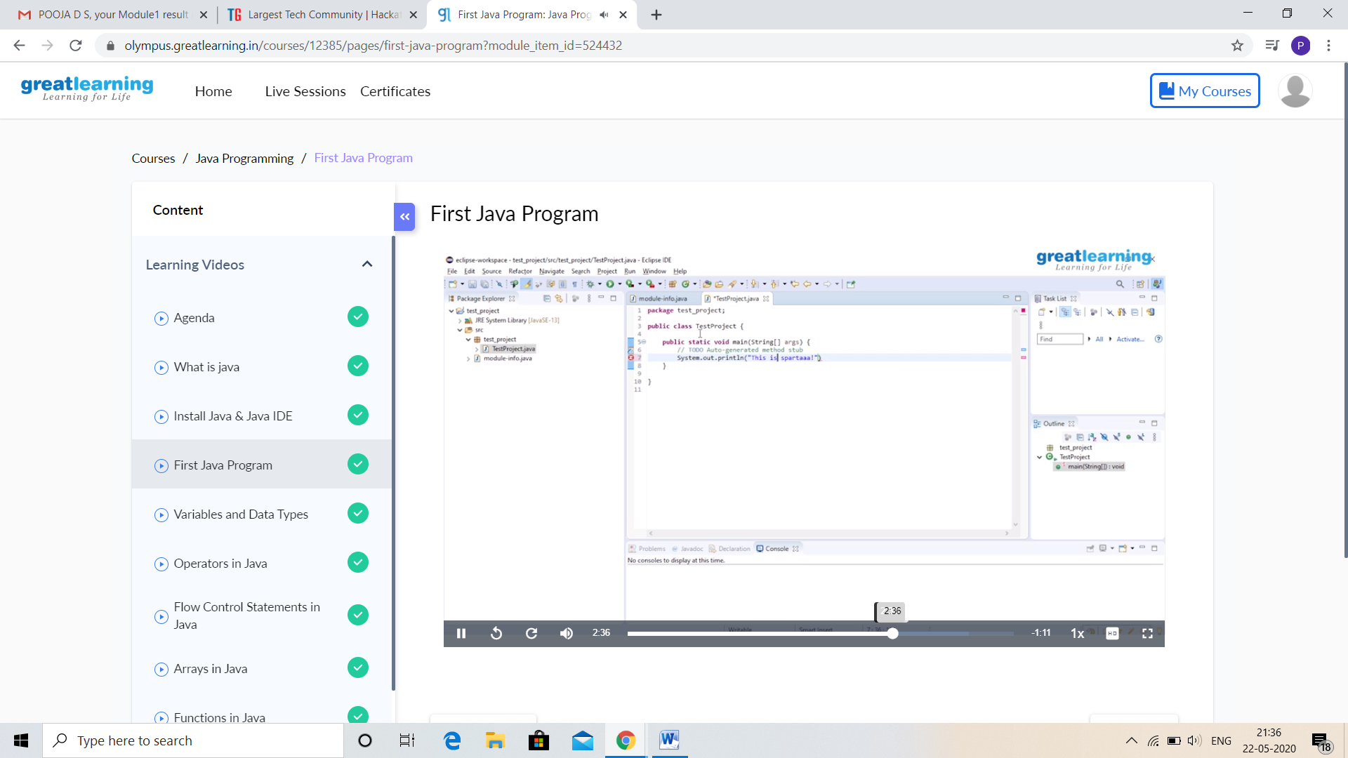

And I Participation in Python Workshop for Beginners. I got good Experience. And this is my certificate

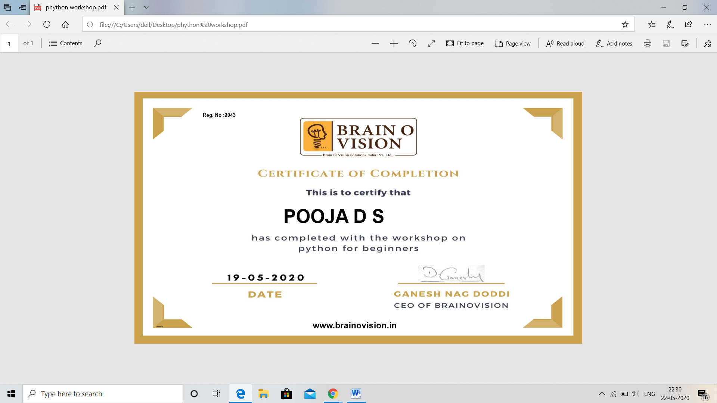

CODING CHALLENGES DETAILS:

Problem statement 1:

Write a C Program to implement various operations on Singly Linked List Stack.

Hint: First Create a single Linked List Stack with the node corresponding to First Element is the base of the stack; and its field must be always Null. When you push First Element, it is the First and it is Based of the stack. Its link must be Null. Top pointer pointing to First. (top = First).

When you push any element, (No need of checking Stack full case because SLL is dynamic) Create a new node called temp using malloc function and insert the a number into Data field, and Link field must be pointing to top; and move the pointer top to point to temp. When you pop, First check for stack Empty. If First == NULL, then Stack Empty. If If First==Null, then Stack Empty. If it is not empty, The pointer temp must be pointing to top. Move the pointer top to top->link delete temp. When you display the stack element, First Check for Stack Empty as in pop operation. If it is not empty, Display all the element of current stack starting from top to First.

Solution: Uploaded in github.

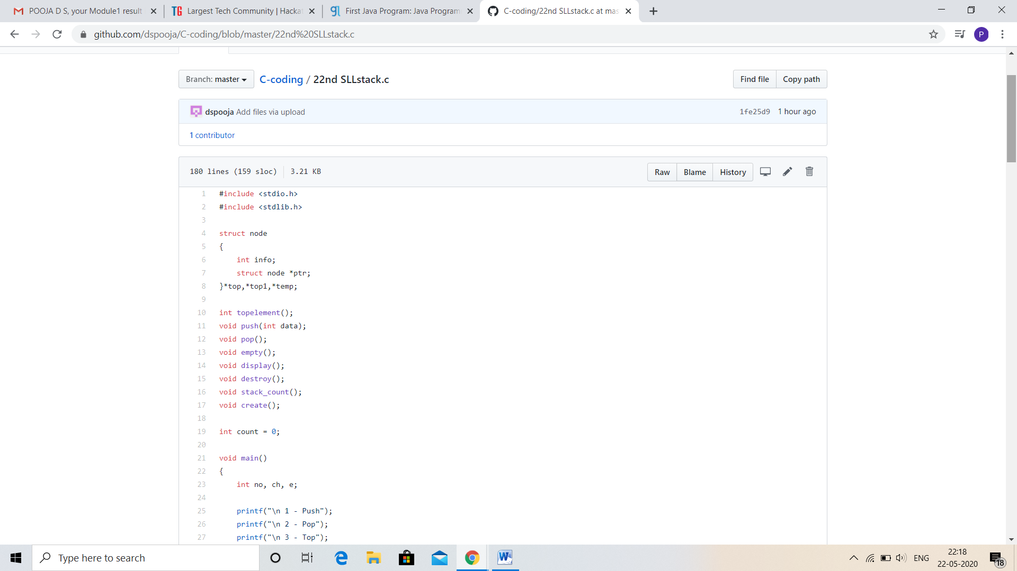

Problem statement 2:

Write a C or Java program to implement round robin type of process scheduling.

Write a C or Java program to implement round robin type of process scheduling.  
Input: Process with burst time, arrival time and specify the time quantum  
Output: Processes scheduled based on the round robin type of scheduling, with its average waiting time.

Solution: Uploaded in github.

